About Section

_____________________________________________________________________________________________

27 stunning acres, friendly animals, and thoughtful, welcoming hospitality... And with so many things to see and do, make sure to stay awhile!

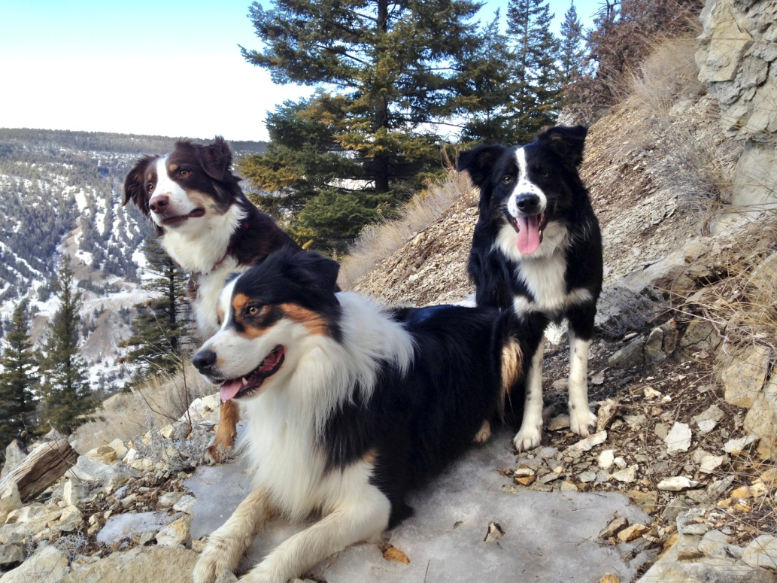
Williams Lake is surrounded by trail-laced hillsides.

Abundant lakes, rivers and mountains are nearby

Mountain biking

Hiking, Trail Running

Paddle and Fish

Animals & Things to Do Images (scroll through)

WELL WORTH THE DRIVE
Farwell Canyon – Gold Rush Trail – Barkerville and Wells – Williams Lake Stampede

